

Hockey Calgary U9 Exhibition and Tournament Game Requests

Table of Contents
Exhibition Games 2
Getting Started 2
Tournament Games 7
Hosting a Tournament? 7
Participating in a Tournament hosted by Non-Calgary Team? 7
Option 1: Two-Four Team Model (2 teams split squad) 7
Option 2: Split squad against 2 different teams 7

Exhibition Games
All exhibition games must be sanctioned by Hockey Calgary. By submitting this online form, communication will be handled through automatic email notifications to all necessary parties, including CRRC or Community Referee Assignors. Once a game is sanctioned, teams will be in compliance with Rule 24(b) of the Hockey Calgary Regulation Handbook. If the request is denied, the Head Coach and manager of teams that proceed without sanction may receive a minimum three game suspension.

The exhibition game request is to be submitted by the just the home team when the game involves two Hockey Calgary teams or by any team playing a game against a non-Hockey Calgary team, regardless of where the game is being played.

Getting Started


- First step is to go to www.hockeycalgary.com .
Figure 1
Select the “Login” button (see Figure 1 above).

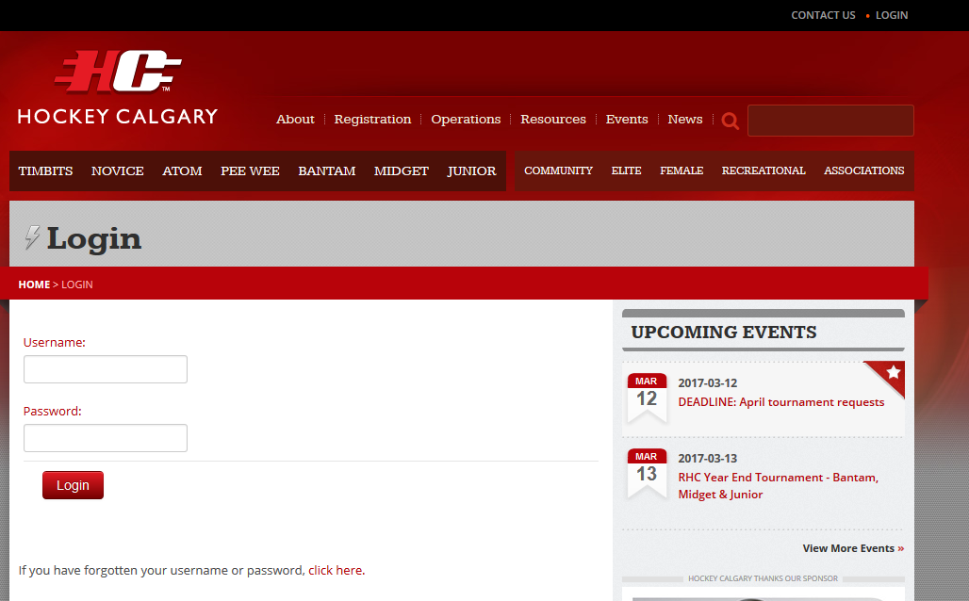

Figure 2
Enter your Username and password in the fields provided and select “Login” (see Figure 2 above).

- When you first logon you will be presented with a list of your previous games, upcoming games and your team roster.
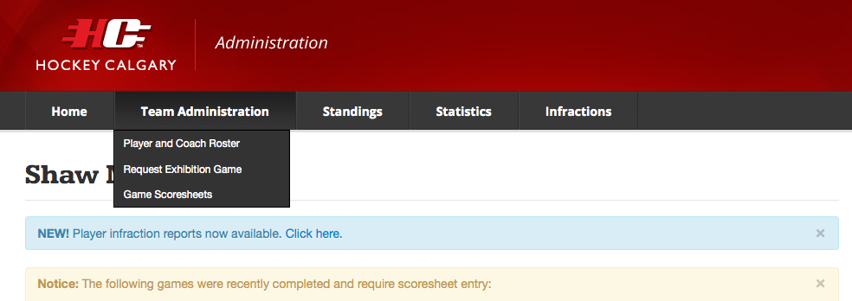
Figure 3

Note the Team Administration Tab at the top of the page (see figure 3 above). Scroll down and select “Request Exhibition Game”.

- All previously sanctioned and upcoming sanctioned exhibition games will display, or it wil indicate that no games have been requested. To request a new Exhibition Game Sanction click the “Request Exhibition Game” button.

- At the top of the form there are important points that explain the process including who is responsible for assigning the on ice officials. Once you have reviewed these points, carefully complete all fields in the form:
  - It is imperative that the Date, Start Time, Duration and Arena be entered very carefully
    - If the Start Time is less than 48 hours prior to the time the form is being submitted, the request will be rejected.
  - Select the appropriate duration of the game in minutes from the pull down.
  - You may request either 2 or 3 officials be assigned to your game.
  - The Age Category and Home Team cannot be changed as they are linked to the Username that is logged.
  - The Visiting Team will provide a number of options in the pull-down list.
    - Hockey Calgary Opponent
      - No: select this if the Visiting Team is from outside Calgary.
      - Yes: select the Association and Team from the drop-down menus
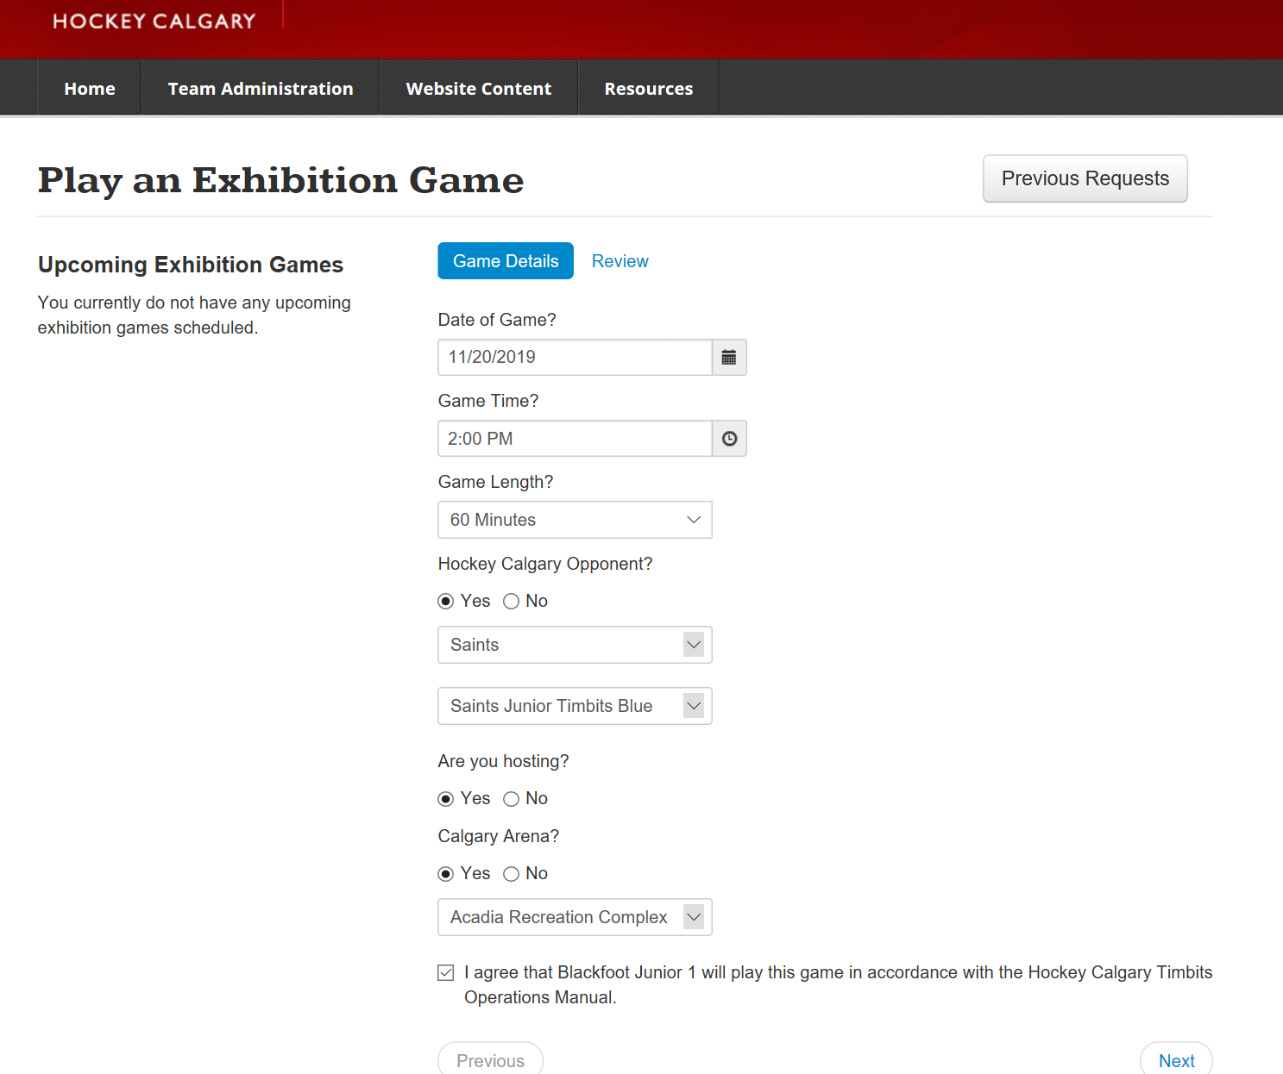

Figure 4

- Review the information entered into each field (see Figure 5, above) and click “Submit” if everything looks correct. If not you can continue making changes until all information is correct. Once “Submit” has been selected it will send an email notification to the following individuals:

  - Team Contacts for both Home and Visiting Teams
  - League Chair (if teams are from different divisions, both League Chairs will be notified)
  - Age Category Governor
  - Council Chair
  - Presidents of both Home and Visiting Teams Associations
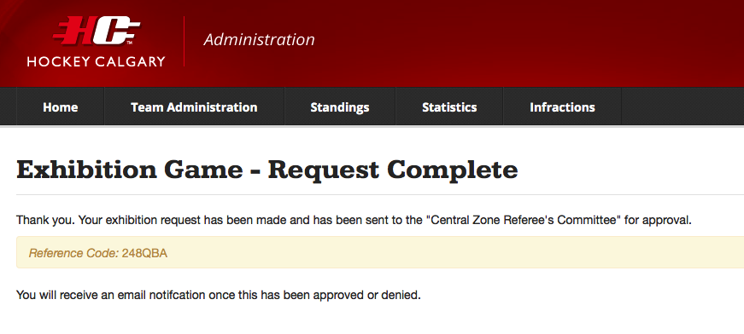
Figure 5
Once you have clicked “Submit” you will get this message indicating your form was submitted successfully.

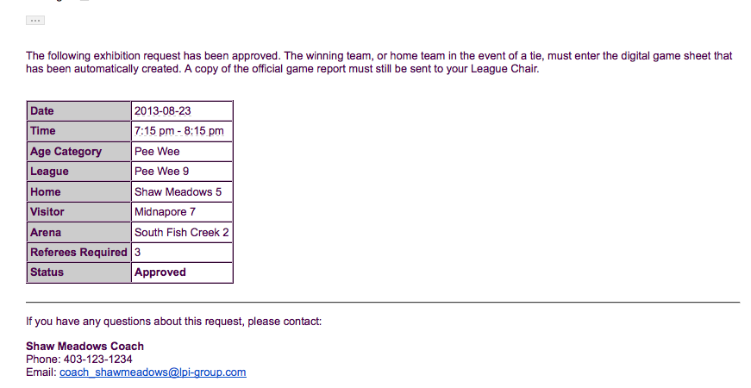
Figure 6
Figure 8 (above) illustrates the email notification if the game has been approved. The game may now be played as scheduled – just ensure you are aware of the referee fees and how they are to be paid. This was explained at the top of the Request Form.
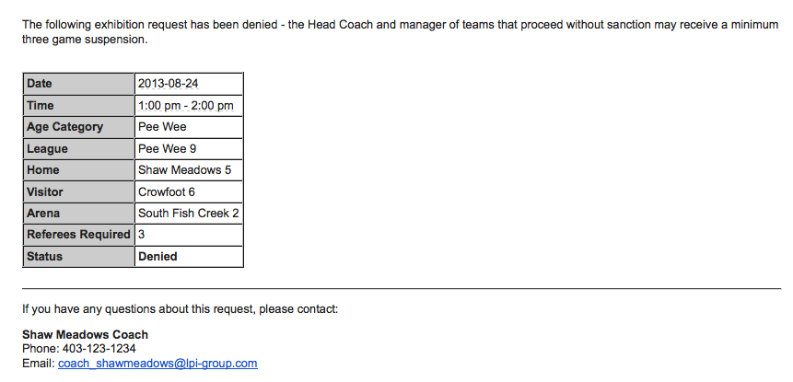

Figure 7
Figure 9 (above) illustrates the email notification if the game has been denied. The game may not be played and the Head Coach and Manager of teams that proceed without sanction may receive a minimum of three game suspension.

- Once the game has been either approved or denied it will now display on the Team dashboard (see Figure 9).
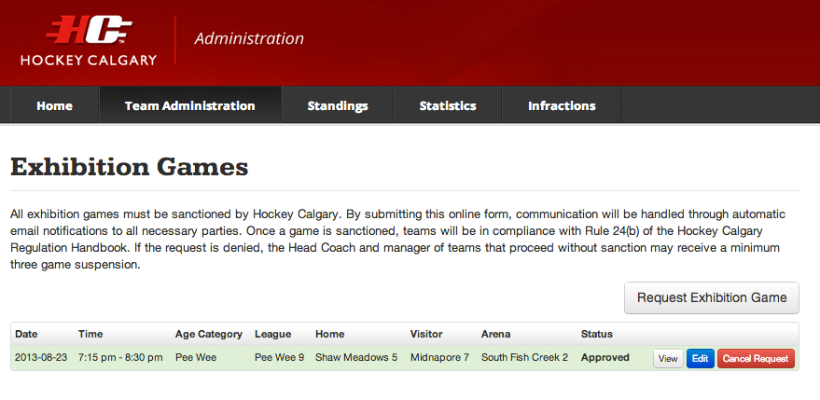
Figure 8

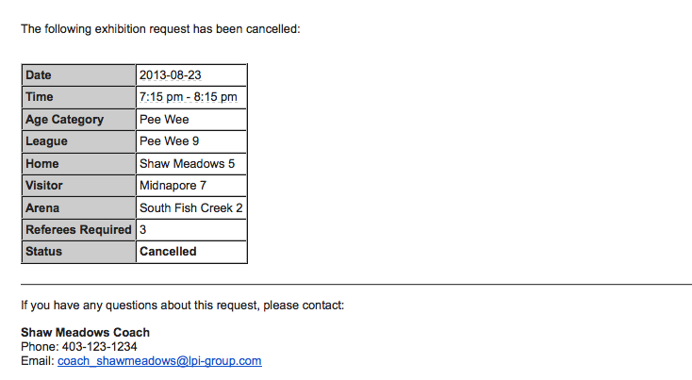
- Approved exhibition games may be cancelled by clicking the “Cancel Request” button and email notifications will be sent to those described in 5). All cancellations for CZRC assigned officials are subject to a $50 charge if the game is cancelled less than 24 hours prior to the start time of the game. Community Referee Coordinators may impose a similar charge, please refer to your Association procedures.

Figure 9
The game will be deleted from the Hockey Calgary website and officials will be cancelled.

Tournament Games
This section is a guide to help you input games and opponents when inputting opponents for the tournament games themselves. For more information hosting the tournament itself, please visit https://www.hockeycalgary.ca/operations/tournaments/hosting-a-tournament

Hosting a Tournament?
- Fill in the standard information Date, Start Time, Duration, Arena, Home and Visiting Teams.

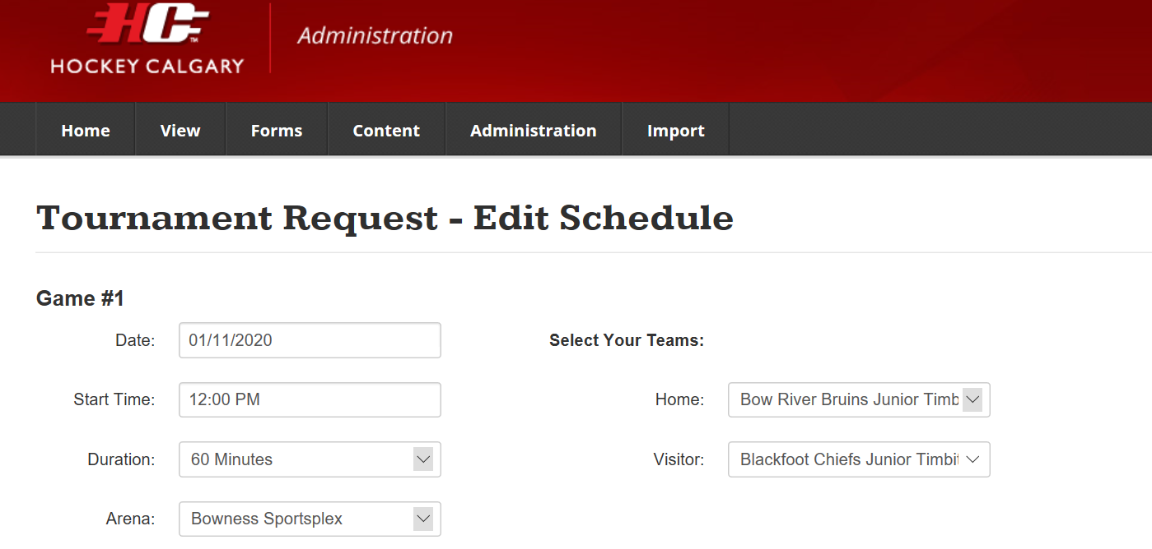
Figure 11

Participating in a Tournament hosted by Non-Calgary Team?

Option 1: Two-Four Team Model (2 teams split squad)
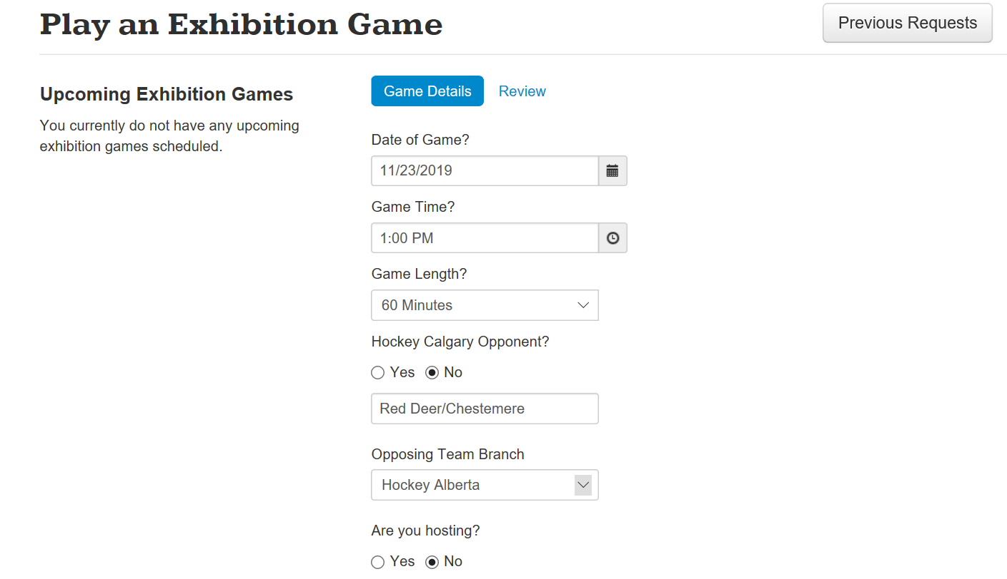
- Inputting game information following the tournament will follow the Exhibition Game procedure found previously in this document

Option 2: Split squad against 2 different teams
There may be instances for tournaments where a hosting team/association will structure their games with 4 teams on the ice. Hockey Calgary recommends registering your team as 2 separate teams in order to provide ample ice time for your players. In this event, you may play two separate teams (likely in rural Associations) during the same ice time. Please take the following steps to ensure only 1 game is counted towards your total.
- Fill in the standard information Date, Start Time, Duration, and Arena
- Hockey Calgary Opponent – Select ‘No’
  - A box will appear requesting an opponent to be typed in. Please type ‘Opponent 1/Opponent 2’ (see Figure 13)
  - Upload a picture/pdf of both game sheets when entering game sheet information
Figure 13

