

Hockey Calgary Timbit Exhibition and Tournament Game Requests

Table of Contents
Exhibition Games 2
Getting Started 2
Option 1 Game Format: Two-Four Team Model 4
Option 2 Game Format: Three-Six Team Model 5
Both Options 6
Tournament Games 9
Hosting a Tournament? 9
Option 1: Two-Four Team Model 9
Option 2: Three-Six Team Model 9
Participating in a Tournament hosted by Non-Calgary Team? 10
Option 1: Two-Four Team Model 10
Option 2: Split squad against 2 different teams 10



Exhibition Games
All exhibition games must be sanctioned by Hockey Calgary. By submitting this online form, communication will be handled through automatic email notifications to all necessary parties, including CZRC or Community Referee Assignors. Once a game is sanctioned, teams will be in compliance with Rule 24(b) of the Hockey Calgary Regulation Handbook. If the request is denied, the Head Coach and manager of teams that proceed without sanction may receive a minimum three game suspension.

The exhibition game request is to be submitted by the just the home team when the game involves two Hockey Calgary teams or by any team playing a game against a non-Hockey Calgary team, regardless of where the game is being played.

Getting Started


- First step is to go to www.hockeycalgary.com .
Figure 1
Select the “Login” button (see Figure 1 above).

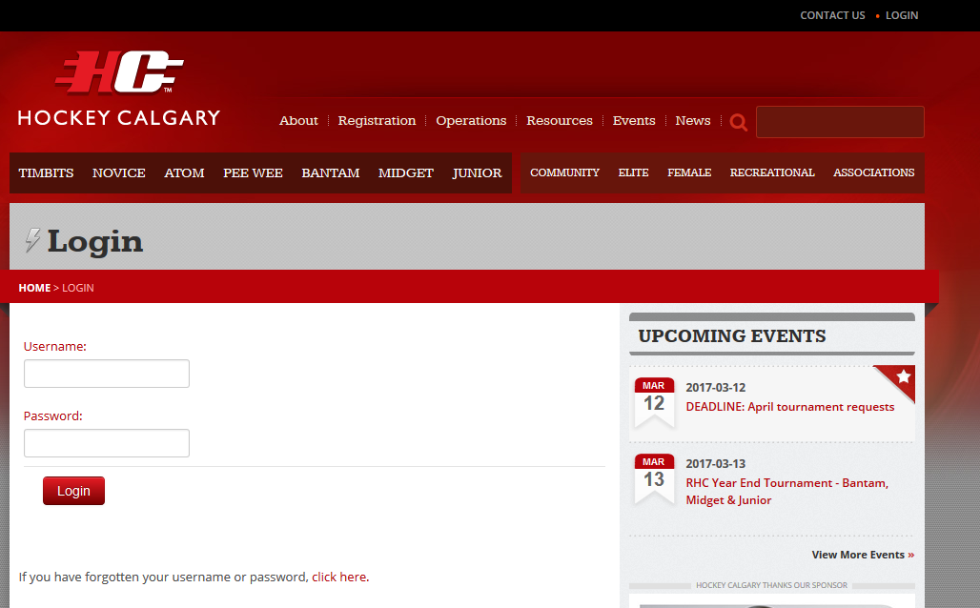

Figure 2
Enter your Username and password in the fields provided and select “Login” (see Figure 2 above).

- When you first logon you will be presented with a list of your previous games, upcoming games and your team roster.
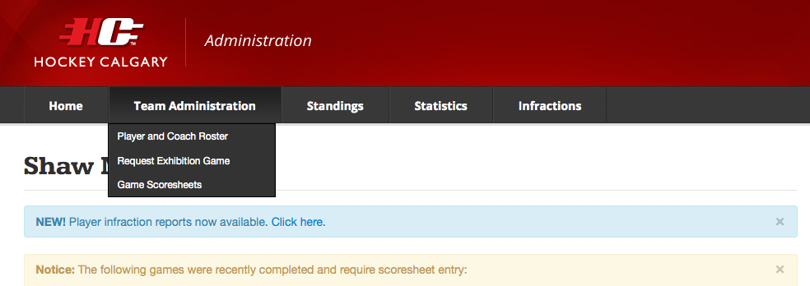
Figure 3
Note the Team Administration Tab at the top of the page (see figure 3 above). Scroll down and select “Request Exhibition Game”.

- All previously sanctioned and upcoming sanctioned exhibition games will display, or it wil indicate that no games have been requested. To request a new Exhibition Game Sanction click the “Request Exhibition Game” button.

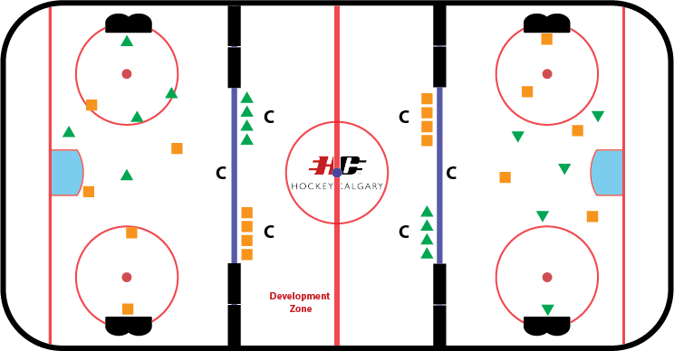
Option 1 Game Format: Two-Four Team Model

- Carefully complete all fields in the form:
  - It is imperative that the Date, Start Time, Duration and Arena be entered very carefully
    - If the Start Time is less than 72 hours prior to the time the form is being submitted, the request will be rejected.
  - Select the appropriate duration of the game in minutes from the pull down.
  - The Age Category and Home Team cannot be changed as they are linked to the Username that is logged.
  - The Visiting Team will provide a number of options in the pull-down list.
    - Hockey Calgary Opponent
      - No: select this if the Visiting Team is from outside Calgary.
      - Yes: select the Association and Team from the drop-down menus
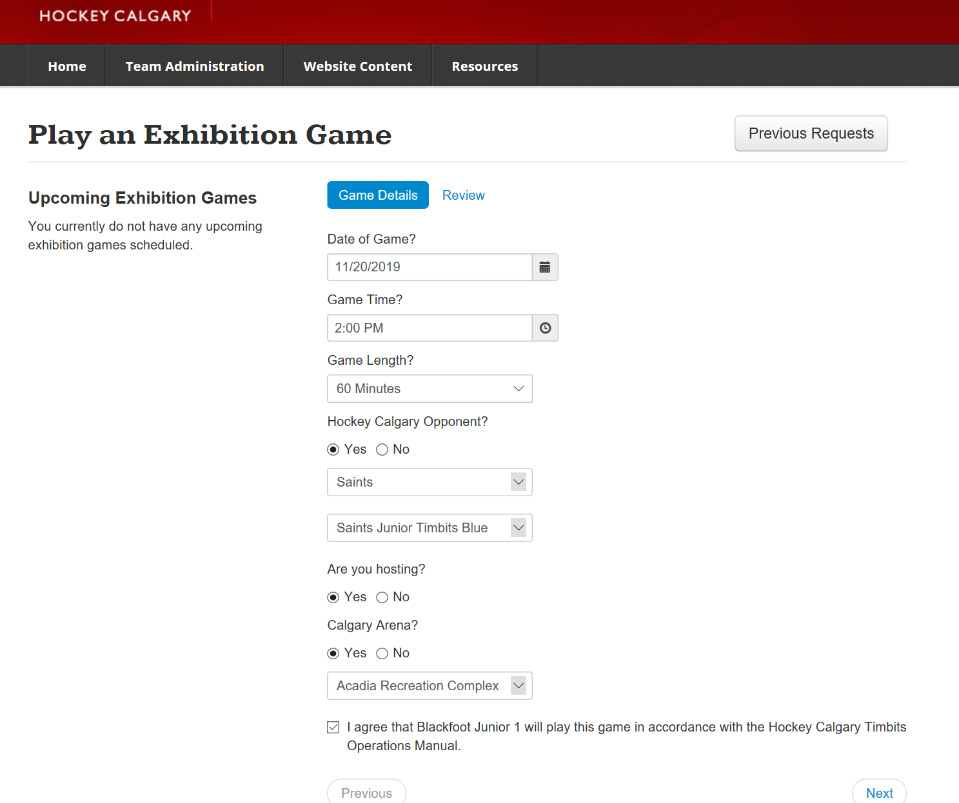

Figure 4

Option 2 Game Format: Three-Six Team Model
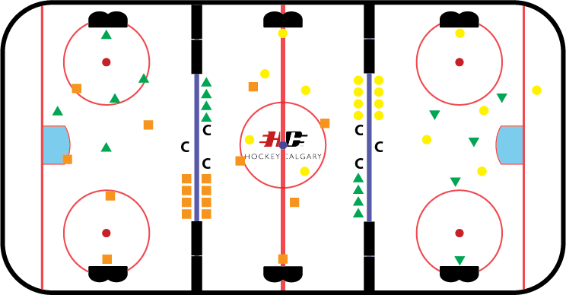
In order to be sure that the game is sanctioned properly so that game totals are properly accounted for, please follow the steps below:
Sample:
- Home Team: Blackfoot Junior Timbits 1
- Visiting Team 1: Saints Junior Timbits Blue
- Visiting Team 2: Bow River Junior Timbits 1

- Two exhibition requests will need to be completed – the Home Team will complete one and the Visiting Team 2 will complete one
- It is imperative that the Date, Start Time, Duration and Arena be entered very carefully
  - If the Start Time is less than 72 hours prior to the time the form is being submitted, the request will be rejected.
- Select the appropriate duration of the game in minutes from the pull down.
- The Age Category and Home Team or Visiting Team 2 cannot be changed as they are linked to the Username that is logged.

- Home Team - Carefully complete all fields in the form:
  - Hockey Calgary Opponent
    - No: select this if the Visiting Team is from outside Calgary.
    - Yes: select the Association and Team from the drop-down menus

Figure 5
- Visiting Team 2 - Carefully complete all fields in the form:
  - Hockey Calgary Opponent – Select ‘No’
    - A box will appear requesting an opponent to be typed in. Please type
‘3rd Team Timbits Game’ (see Figure 6 below)

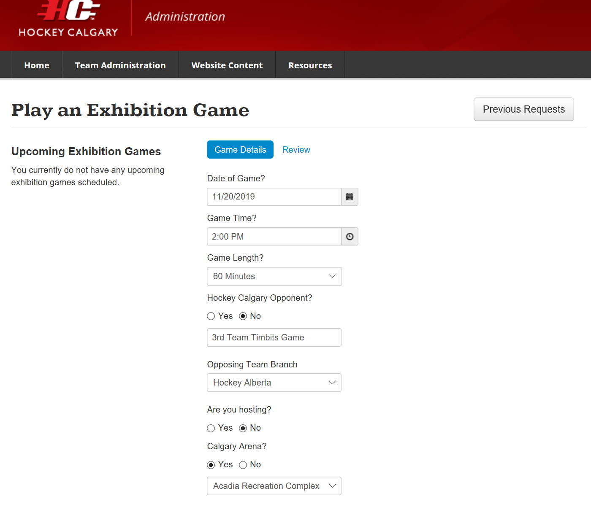
Figure 6

Both Options
- Review the information entered into each field (see Figure 5, above) and click “Submit” if everything looks correct. If not you can continue making changes until all information is correct. Once “Submit” has been selected it will send an email notification to the following individuals:

  - Team Contacts for both Home and Visiting Teams
  - League Chair (if teams are from different divisions, both League Chairs will be notified)
  - Age Category Governor
  - Council Chair
  - Presidents of both Home and Visiting Teams Associations

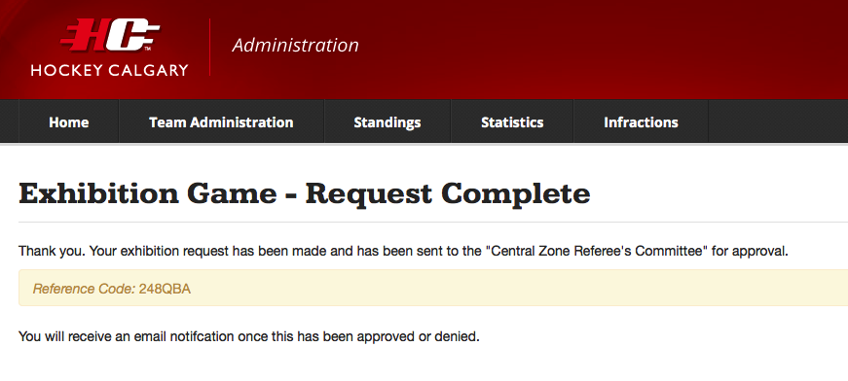
Figure 7
Once you have clicked “Submit” you will get this message indicating your form was submitted successfully.

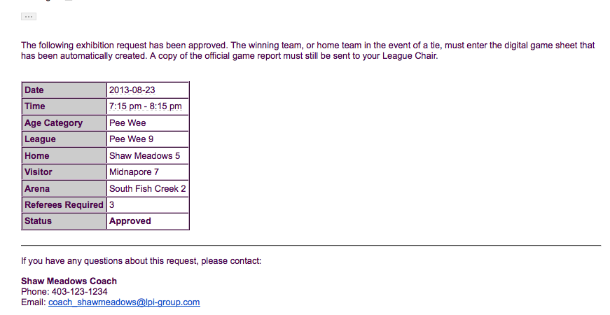
Figure 8
Figure 8 (above) illustrates the email notification if the game has been approved. The game may now be played as scheduled – just ensure you are aware of the referee fees and how they are to be paid. This was explained at the top of the Request Form.
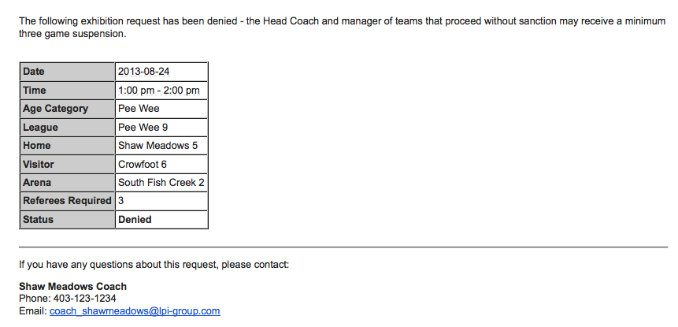

Figure 9
Figure 9 (above) illustrates the email notification if the game has been denied. The game may not be played and the Head Coach and Manager of teams that proceed without sanction may receive a minimum of three game suspension.

- Once the game has been either approved or denied it will now display on the Team dashboard (see Figure 9).
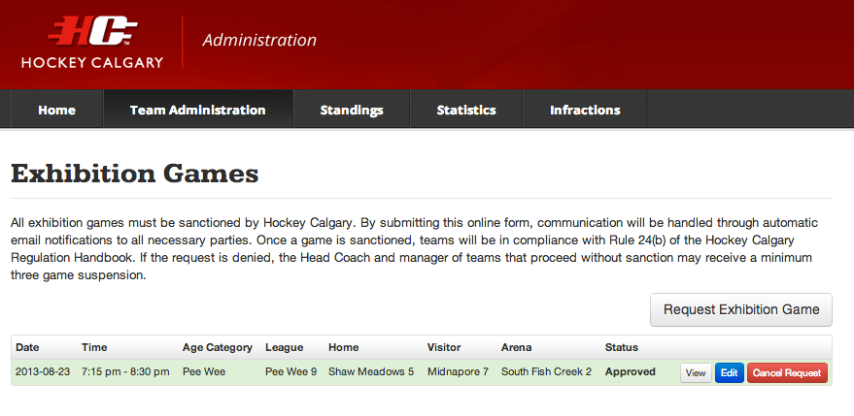
Figure 10

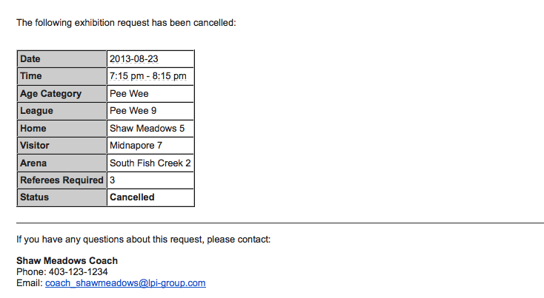
- Approved exhibition games may be cancelled by clicking the “Cancel Request” button and email notifications will be sent to those described in 5). All cancellations for CZRC assigned officials are subject to a $50 charge if the game is cancelled less than 24 hours prior to the start time of the game. Community Referee Coordinators may impose a similar charge, please refer to your Association procedures.

Figure 11
The game will be deleted from the Hockey Calgary website and officials will be cancelled.

Tournament Games
This section is a guide to help you input games and opponents when inputting opponents for the tournament games themselves. For more information hosting the tournament itself, please visit https://www.hockeycalgary.ca/operations/tournaments/hosting-a-tournament

Hosting a Tournament?

Option 1: Two-Four Team Model
- Fill in the standard information Date, Start Time, Duration, Arena, Home and Visiting Teams.

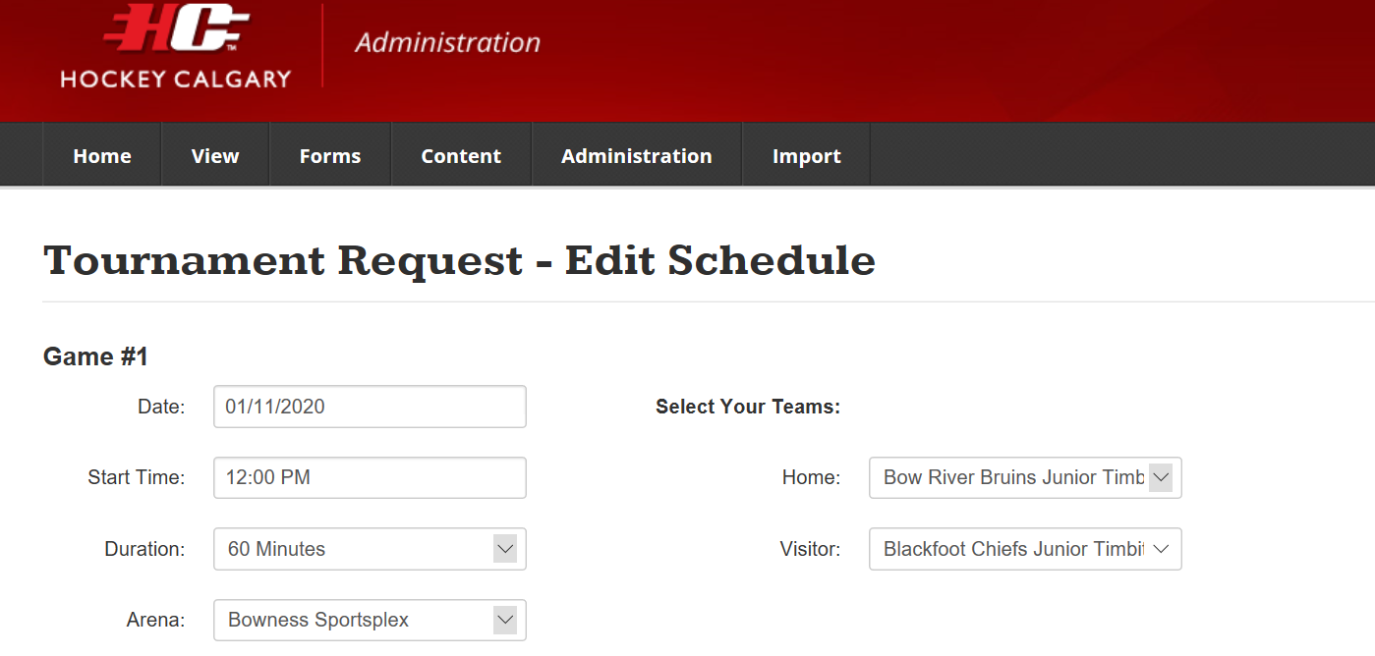
Figure 11

Option 2: Three-Six Team Model
In order to be sure that the game is sanctioned properly so that game totals are properly accounted for, please follow the steps below:
Sample:
- Home Team: Bow River Junior Timbits 1
- Visiting Team 1: Blackfoot Chiefs Junior Timbits
- Visiting Team 2: Springbank Rockies Junior Timbits

- Two game slots will be entered for the same ice time
- Fill in the standard information Date, Start Time, Duration, and Arena for both games
- Game #1 – Select teams for Home Team and Visiting Team 1
- Game #2 – Select Visiting team 2 as the Visiting Team and leave the Home Team as To Be Determined (see Figure 12 below)
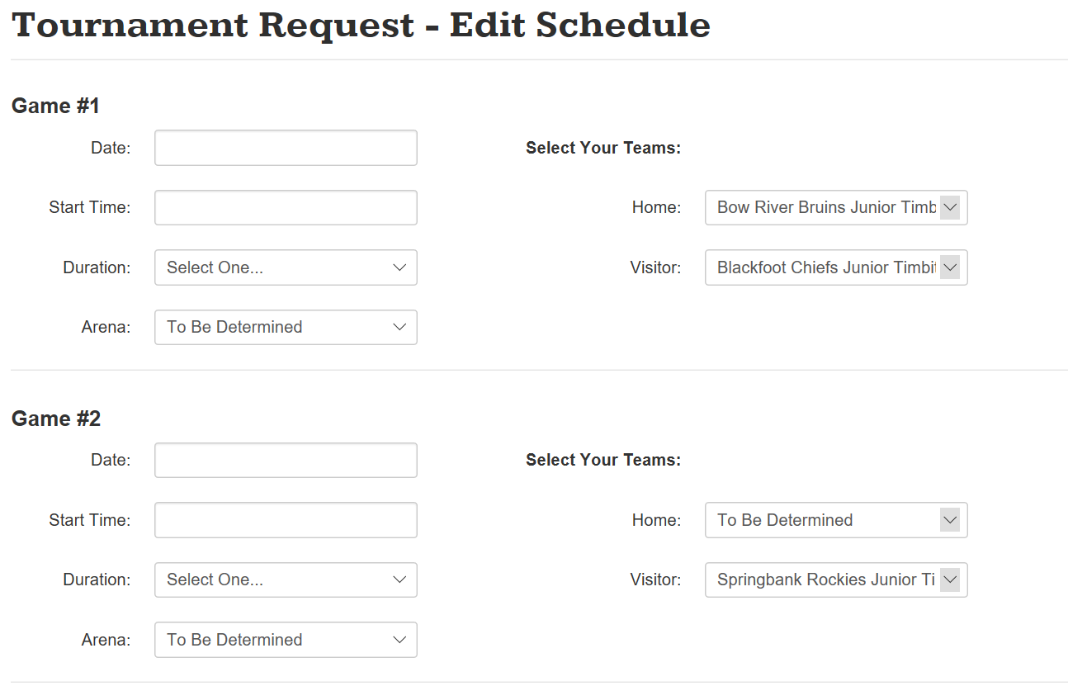
Figure 12

Participating in a Tournament hosted by Non-Calgary Team?

Option 1: Two-Four Team Model
- Inputting game information following the tournament will follow the Exhibition Game procedure found previously in this document

Option 2: Split squad against 2 different teams
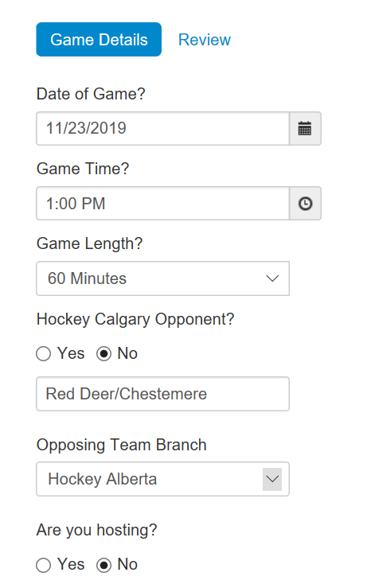
There may be instances for tournaments where a hosting team/association will structure their games with 4 teams on the ice. Hockey Calgary recommends registering your team as 2 separate teams in order to provide ample ice time for your players. In this event, you may play two separate teams (likely in rural Associations) during the same ice time. Please take the following steps to ensure only 1 game is counted towards your total.
- Fill in the standard information Date, Start Time, Duration, and Arena
- Hockey Calgary Opponent – Select ‘No’
  - A box will appear requesting an opponent to be typed in. Please type ‘Opponent 1/Opponent 2’ (see Figure 13)
  - Upload a picture/pdf of both game sheets when entering gamesheet information
Figure 13

